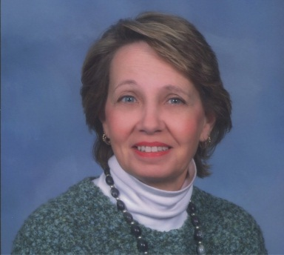

LEE B. (LEVINA) LASICH
CANDIDATE FOR COUNCIL
THIRD WARD, CITY OF CLAIRTON

May, 2013

Dear Voters:

I am writing to introduce myself to those I don’t have the privilege of knowing. My name is Lee (Levina) Lasich and I am a Candidate for the Third Ward Council seat. I have been a resident of the City of Clairton since a small child and the Third Ward since 1975 when my late husband, Butch Lasich, and I bought our home in Colonial Village. I am a notary public and legal secretary with over 40 years’ experience in various areas of the legal profession. I am also a Parishioner and Eucharistic Minister of St. Clare of Assisi Parish as well as a member of its Pastoral Council, its Executive Committee and Chair of its Apostolate Committee. I am an active member of the Eastman Community Advisory Panel and its Newsletter Committee, the Clean Water Action and REACH Mon Valley Groups and Clairton Crime Watch, and have been for approximately nine years. I have been a member of Clairton’s Personnel Board and a social member of the American Legion. I’ve helped at the Community Day festivities and the Chamber of Commerce 5K/2K Walk-Run.
In the past three years, I have attended the monthly meetings of the City Council where I asked many questions and I served the first Right-to-Know Request on the City. After review of records, I questioned the amount of back real estate taxes owing to the City because of non-collection. I asked their future plans for collection of these outrageous taxes and have questioned them on many issues over the past three years.
There are many issues in our City that have been dealt with over the past year. Due to the fact that two new members of Council were elected, motions were passed that benefited the whole City. While the new members and the Mayor voted to take steps to collect those back taxes and outstanding refuse bills, the incumbent members voted “no” because they, themselves, owe.
I do not need to be forced to admit that I owe moneys to the City and School District of Clairton. My taxes and bills are all paid and current. I do not need the taxpayers to purchase a cellphone for me. I have my own; but I would only ask for a small stipend to cover the difference in plans.
It’s time for positive changeS IN our Third Ward! I ask that when you vote on Tuesday, May 21, 2013, consider casting your vote for someone new—NAMELY, me! I only can promise that I will help Council continue moving forward with those positive changes.
Remember even though I’m a Democrat, Republicans can vote for me as a “write-in” candidate on the ballot.
Thank you.

Lee Lasich
Lee B. Lasich
Candidate for Council
Third Ward

