September 2013

Dear RCT Members:

This letter is to first thank you for being involved with RCT – Rebuilding Clairton Together.

We have been together as an organization for one year as of June 1, 2013. Some of you have been with us from the beginning and some of you have just joined; but together, we are making a difference!

RCT was formed to help rebuild, restore, and refresh Clairton . . . the key word here is “help”.
It takes many to do the work that is needed to accomplish this task. We have set out to help our local government and community leaders bring change to our city.

We wanted to show that you don’t have to have a “title” to make a difference; each citizen can contribute to change. We selected a project that was not already being addressed; that project was Memorial Hill in Clairton Park.

WHAT WE HAVE DONE

Together, we have managed to accomplish several objectives. During the past year, we:

- Chose Memorial Hill as our 1st and most visible project:

  - Weeded the flower bed at the base of the fountain (the fountain is decorative only as the water was turned off decades ago)
  - Uncovered walkways that were overgrown with grass and weeds
  - Removed grass and weeds from memorial markers for veterans
  - Cut and maintained grass
  - Planted bulbs and flowers in the flower bed at the base of the fountain
  - Communicated respect for our veterans and helped to keep the promise made decades ago: to remember and honor them for their sacrifices
  - Set an example that just “regular” people can make a difference.

- Established our web site: www.myclairton.com, which performs the following functions:

    - Updates readers of positive community events and news
    - Advertises Clairton businesses
    - Functions as a “virtual office and resource center” for information on Clairton
    - Helps serve as a bridge to our city government site
    - Updates readers on our organization, mission, and progress
    - Functions as a way to spark interest in others to help improve our city.

- Established a “sister” site on Facebook at “RCT – Rebuilding Clairton Together” to provide a more “interactive” venue to communicate events and news. (The web site and facebook site have different audiences.)

- With the help of our attorney, Dave Allison, we were incorporated in December 2012.

- Attended regional meetings of Mon-Valley Community-Police Relations Forum established by U.S. Attorney David Hickton, Department of Justice.

- Attended Clairton City Council workshop meetings and council meetings.

Our dedication to Memorial Hill has not gone un-noticed. Recently, we were approached by the Home Depot Foundation for Veterans to help us further the restoration. We are expecting this effort to begin shortly.
While RCT projects are accomplished with volunteer labor, there are expenses associated with them such as gasoline for lawn mowers, repairs, supplies (weed killer, mulch, and topsoil), maintenance, web site and legal fees, postage, and so on.

WHAT WE ARE DOING

We are currently planning a yard sale on September 28th at 1105 McPherson Avenue in Clairton to help cover expenses and build funds for future projects. We are looking for support in communicating this event as well as donations of any gently used items you can spare. Please pass on the word.

LOOKING FORWARD

Volunteers are needed to:

- donate items to be sold at the yard sale in September
- make phone calls periodically
- maintain Memorial Hill (mostly weeding and grass cutting)
- participate in developing ideas for future events
- attend council workshops and council meetings.

We are sending this letter by way of the latest contact information we have listed for you.

If you would like receive further communications by way of a different means, please update your contact information and indicate your communication preference.

Name: ___________________________________

Facebook Name: ___________________________

Email address: ____________________________

Phone number(s): (Home) __________________ (Cell) ________________________

Street Address: _______________________________________________________

Do you have any objections to sharing your contact information (name and email address) with other members? The reason we are asking is because it would be great to be able to share ideas with each other via a distribution list. If you cannot share your contact information, please let us know when you update it.

You may submit your contact information electronically (cityofprayer@aol.com) or mail to 1105 McPherson Avenue, Clairton, PA 15025. If you cannot support the yard sale but wish to make a donation, please write your check to “Rebuilding Clairton Together”.

We sincerely appreciate each of you having an interest in Clairton and believing that together we can make a difference. We have received many, many compliments and thanks on the work we have done on Memorial Hill and want you to know that it is appreciated by others as well.

Again, thank you for all of your hard work and dedication. And PLEASE . . . if you have ideas that you feel are feasible for our group to accomplish, please let us know. Hope to hear from you and share ideas and results soon.

Sincerely,

Cathy A. Nickolich White, President Joanie Jordan, Secretary / Treasurer

Cheryl Hill Ehlers, Director Sharon Mihoces Figueroa, Director

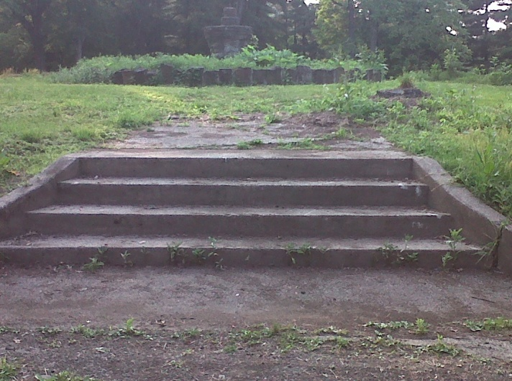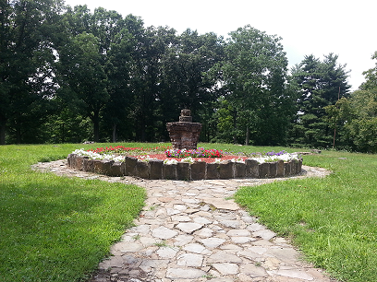
Memorial Hill before RCT Memorial Hill after RCT

